PERTEMUAN 9 PEMROGRAMAN JAVA

PERCABANGAN

Sebuah statement yang akan dipilih berdasarkan pilihan terhadap suatu kondisi yang menuju ke proses tersebut. Jika keadaan kondisi yang diminta benar atau true maka akan ada sebuah statement yang dijalankan dan sebalikny jika salah atau false maka akan menjalankan statement yang berbeda. Biasa pada kebanyakan Bahasa – Bahasa pemrograman mengunakan if, if else, if else if else, switch case, dll.

IF ELSE IF ELSE : Membuat 2 percabangan dengan satu kondisi

Contoh IF ELSE IF ELSE : if (kondisi)

{ jalankan ini }

if else

{ jalankan ini }

If else

{ jalankan ini }

Else

{ jalankan ini }

Contoh Switch Case : Switch ( kondisi ) {

Case A:

Jalankan ini A

Break;

Case B:

Jalankan ini B

Break;

Case C:

Jalankan ini C

Break;

Default: Jalankan jika tidak ada case yang terpilih;

}

Latihan 1

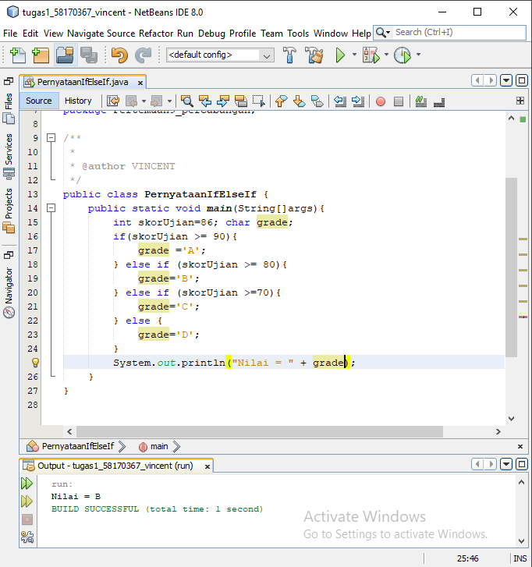

package Pertemuan9_percabangan;

/**

*

* @author VINCENT

*/

public class PernyataanIfElseIf {

public static void main(String[]args){

int skorUjian = 86;

char grade;

System.out.print("Masukkan Nilai = ");

skorUjian = input.nextInt();

if(skorUjian >= 90){

grade ='A';

} else if (skorUjian >= 80){

grade='B';

} else if (skorUjian >=70){

grade='C';

} else {

grade='D';

}

System.out.println("Nilai = " + grade);

}

}

Kasus 1

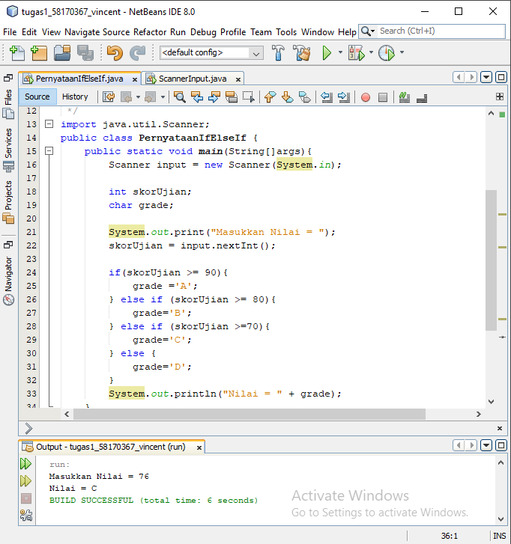

import java.util.Scanner;

public class PernyataanIfElseIf {

public static void main(String[]args){

Scanner input = new Scanner(System.in);

int skorUjian;

char grade;

System.out.print("Masukkan Nilai = ");

skorUjian = input.nextInt();

if(skorUjian >= 90){

grade ='A';

} else if (skorUjian >= 80){

grade='B';

} else if (skorUjian >=70){

grade='C';

} else {

grade='D';

}

System.out.println("Nilai = " + grade);

}

}

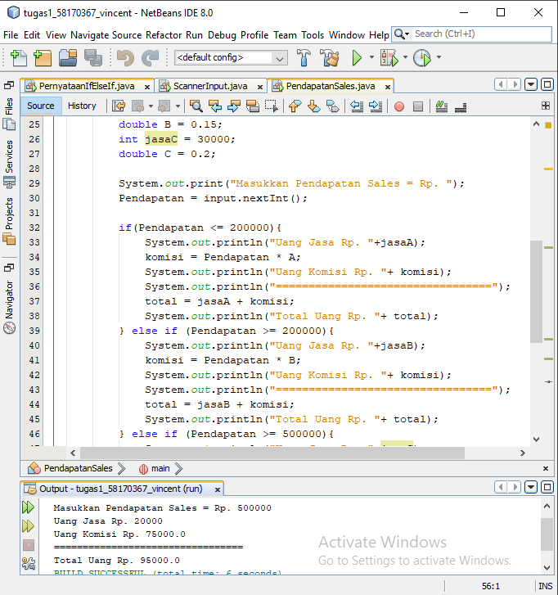

import java.util.Scanner;

/**

*

* @author VINCENT

*/

import java.util.Scanner;

public class PendapatanSales {

public static void main(String[]args){

Scanner input = new Scanner(System.in);

int Pendapatan ;

double komisi, total;

int jasaA = 10000;

double A = 0.1;

int jasaB = 20000;

double B = 0.15;

int jasaC = 30000;

double C = 0.2;

System.out.print("Masukkan Pendapatan Sales = Rp. ");

Pendapatan = input.nextInt();

if(Pendapatan <= 200000){

System.out.println("Uang Jasa Rp. "+jasaA);

komisi = Pendapatan * A;

System.out.println("Uang Komisi Rp. "+ komisi);

System.out.println("=================================");

total = jasaA + komisi;

System.out.println("Total Uang Rp. "+ total);

} else if (Pendapatan >= 200000){

System.out.println("Uang Jasa Rp. "+jasaB);

komisi = Pendapatan * B;

System.out.println("Uang Komisi Rp. "+ komisi);

System.out.println("=================================");

total = jasaB + komisi;

System.out.println("Total Uang Rp. "+ total);

} else if (Pendapatan >= 500000){

System.out.println("Uang Jasa Rp. "+jasaC);

komisi = Pendapatan * C;

System.out.println("Uang Komisi Rp. "+ komisi);

System.out.println("=================================");

total = jasaC + komisi;

System.out.println("Total Uang Rp. "+ total);

} else {

System.out.println("WAW");

}

}

}

Kasus 3

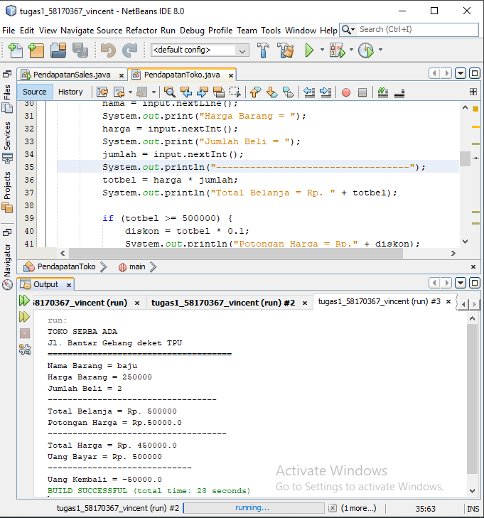

import java.util.Scanner;

public class PendapatanToko {

public static void main(String[] args) {

Scanner input = new Scanner(System.in);

String nama;

int harga, jumlah, totbel, ubay;

double diskon, tothar, ukem;

System.out.println("TOKO SERBA ADA");

System.out.println("Jl. Bantar Gebang deket TPU");

System.out.println("=====================================");

System.out.print("Nama Barang = ");

nama = input.nextLine();

System.out.print("Harga Barang = ");

harga = input.nextInt();

System.out.print("Jumlah Beli = ");

jumlah = input.nextInt();

System.out.println("----------------------------------");

totbel = harga * jumlah;

System.out.println("Total Belanja = Rp. " + totbel);

if (totbel >= 500000) {

diskon = totbel * 0.1;

System.out.println("Potongan Harga = Rp." + diskon);

System.out.println("------------------------------------");

tothar = totbel - diskon;

System.out.println("Total Harga = Rp. " + tothar);

System.out.print("Uang Bayar = Rp. ");

ubay = input.nextInt();

System.out.println("-----------------------------");

ukem = tothar - ubay;

System.out.println("Uang Kembali = " + ukem);

} else if (totbel >= 300000) {

diskon = totbel * 0.06;

System.out.println("Potongan Harga = Rp." + diskon);

System.out.println("------------------------------------");

tothar = totbel - diskon;

System.out.println("Total Harga = Rp. " + tothar);

System.out.print("Uang Bayar = Rp. ");

ubay = input.nextInt();

System.out.println("-----------------------------");

ukem = tothar - ubay;

System.out.println("Uang Kembali = " + ukem);

} else if (totbel >= 150000) {

diskon = totbel * 0.03;

System.out.println("Potongan Harga = Rp." + diskon);

System.out.println("------------------------------------");

tothar = totbel - diskon;

System.out.println("Total Harga = Rp. " + tothar);

System.out.print("Uang Bayar = Rp. ");

ubay = input.nextInt();

System.out.println("-----------------------------");

ukem = tothar - ubay;

System.out.println("Uang Kembali = " + ukem);

} else if (totbel >= 100000) {

diskon = totbel * 0.01;

System.out.println("Potongan Harga = Rp." + diskon);

System.out.println("------------------------------------");

tothar = totbel - diskon;

System.out.println("Total Harga = Rp. " + tothar);

System.out.print("Uang Bayar = Rp. ");

ubay = input.nextInt();

System.out.println("-----------------------------");

ukem = tothar - ubay;

System.out.println("Uang Kembali = " + ukem);

} else {

System.out.println("Tidak Dapat Diskon");

}

}

}

Kasus 4

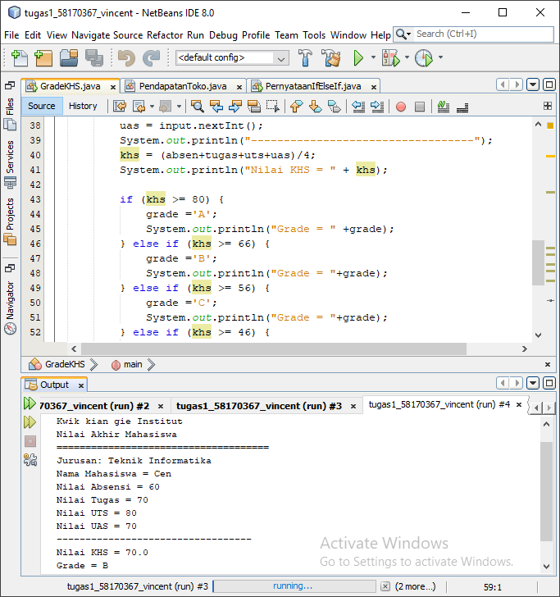

public class GradeKHS {

public static void main(String[] args) {

Scanner input = new Scanner(System.in);

String nama;

double absen, tugas, uts, uas, khs;

char grade;

System.out.println("Kwik kian gie Institut");

System.out.println("Nilai Akhir Mahasiswa");

System.out.println("=====================================");

System.out.println("Jurusan: Teknik Informatika");

System.out.print("Nama Mahasiswa = ");

nama = input.nextLine();

System.out.print("Nilai Absensi = ");

absen = input.nextInt();

System.out.print("Nilai Tugas = ");

tugas = input.nextInt();

System.out.print("Nilai UTS = ");

uts = input.nextInt();

System.out.print("Nilai UAS = ");

uas = input.nextInt();

System.out.println("----------------------------------");

khs = (absen+tugas+uts+uas)/4;

System.out.println("Nilai KHS = " + khs);

if (khs >= 80) {

grade ='A';

System.out.println("Grade = " +grade);

} else if (khs >= 66) {

grade ='B';

System.out.println("Grade = "+grade);

} else if (khs >= 56) {

grade ='C';

System.out.println("Grade = "+grade);

} else if (khs >= 46) {

grade ='D';

System.out.println("Grade = "+grade);

} else {

grade ='E';

System.out.println("Grade= "+grade);

}

}

}

Kasus 5

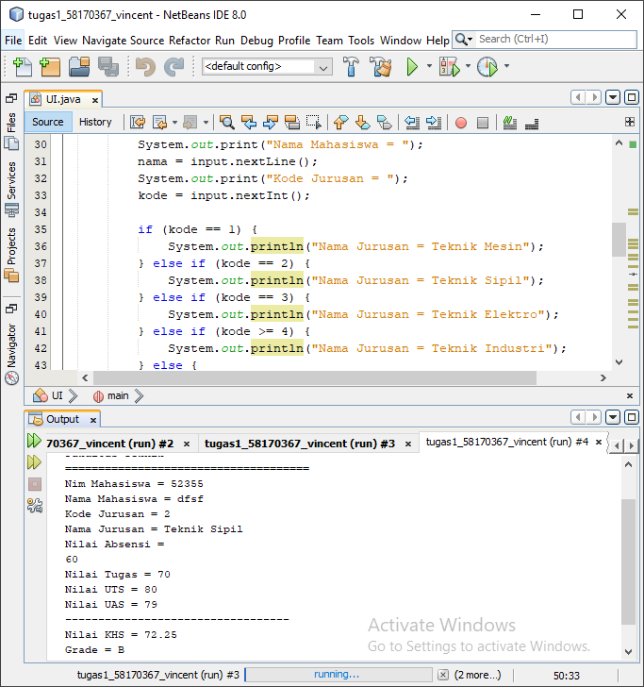

import java.util.Scanner;

public class UI {

public static void main(String[] args) {

Scanner input = new Scanner(System.in);

String nama, nim;

int kode;

double absen, tugas, uts, uas, khs;

char grade;

System.out.println("Univ Indonesia");

System.out.println("Fakultas Teknik");

System.out.println("=====================================");

System.out.print("Nim Mahasiswa = ");

nim = input.nextLine ();

System.out.print("Nama Mahasiswa = ");

nama = input.nextLine();

System.out.print("Kode Jurusan = ");

kode = input.nextInt();

if (kode == 1) {

System.out.println("Nama Jurusan = Teknik Mesin");

} else if (kode == 2) {

System.out.println("Nama Jurusan = Teknik Sipil");

} else if (kode == 3) {

System.out.println("Nama Jurusan = Teknik Elektro");

} else if (kode >= 4) {

System.out.println("Nama Jurusan = Teknik Industri");

} else {

System.out.println("Nama Jurusan = Salah Kode");

}

System.out.println("Nilai Absensi = ");

absen = input.nextInt ();

System.out.print("Nilai Tugas = ");

tugas = input.nextInt();

System.out.print("Nilai UTS = ");

uts = input.nextInt();

System.out.print("Nilai UAS = ");

uas = input.nextInt();

System.out.println("----------------------------------");

khs = (absen+tugas+uts+uas)/4;

System.out.println("Nilai KHS = " + khs);

if (khs >= 80) {

grade ='A';

System.out.println("Grade = " +grade);

} else if (khs >= 66) {

grade ='B';

System.out.println("Grade = "+grade);

} else if (khs >= 56) {

grade ='C';

System.out.println("Grade = "+grade);

} else if (khs >= 46) {

grade ='D';

System.out.println("Grade = "+grade);

} else {

grade ='E';

System.out.println("Grade= "+grade);

}

}

}

Latihan 2

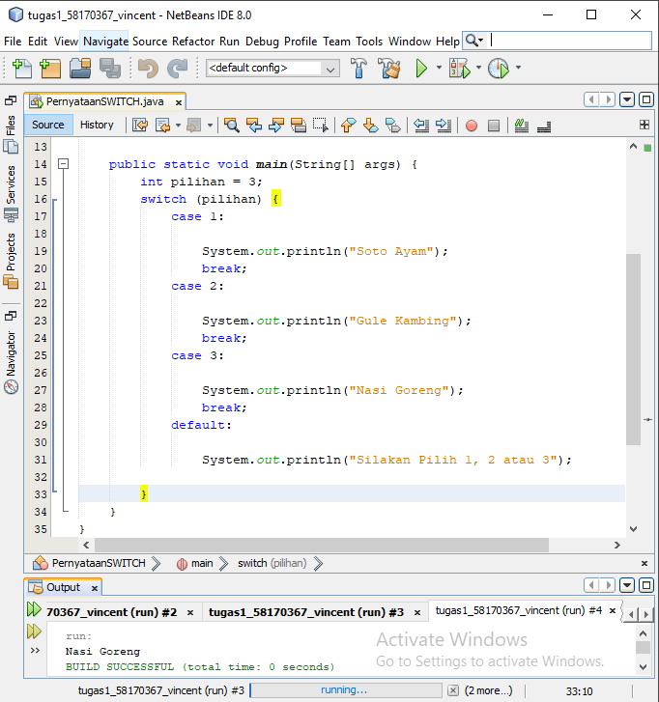

package Pertemuan9_percabangan;

/**

*

* @author VINCENT

*/

public class PernyataanSWITCH {

public static void main(String[] args) {

int pilihan = 3;

switch (pilihan) {

case 1:

System.out.println("Soto Ayam");

break;

case 2:

System.out.println("Gule Kambing");

break;

case 3:

System.out.println("Nasi Goreng");

break;

default:

System.out.println("Silakan Pilih 1, 2 atau 3");

}

}

}

Latihan 3

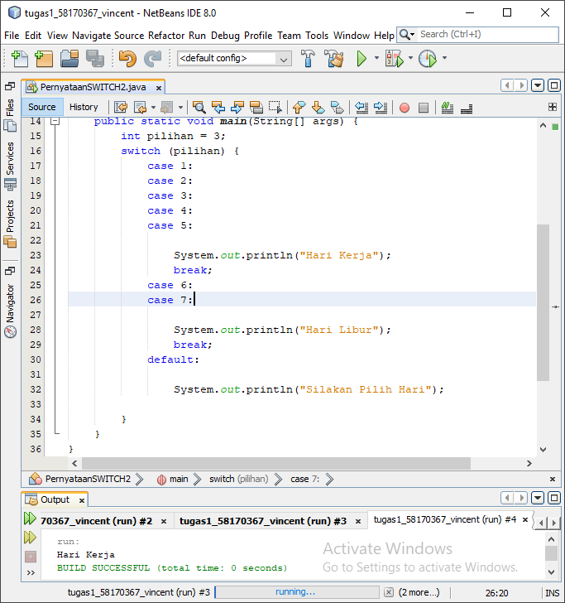

/**

*

* @author VINCENT

*/

public class PernyataanSWITCH2 {

public static void main(String[] args) {

int pilihan = 3;

switch (pilihan) {

case 1:

case 2:

case 3:

case 4:

case 5:

System.out.println("Hari Kerja");

break;

case 6:

case 7:

System.out.println("Hari Libur");

break;

default:

System.out.println("Silakan Pilih Hari");

}

}

}

Latihan 4

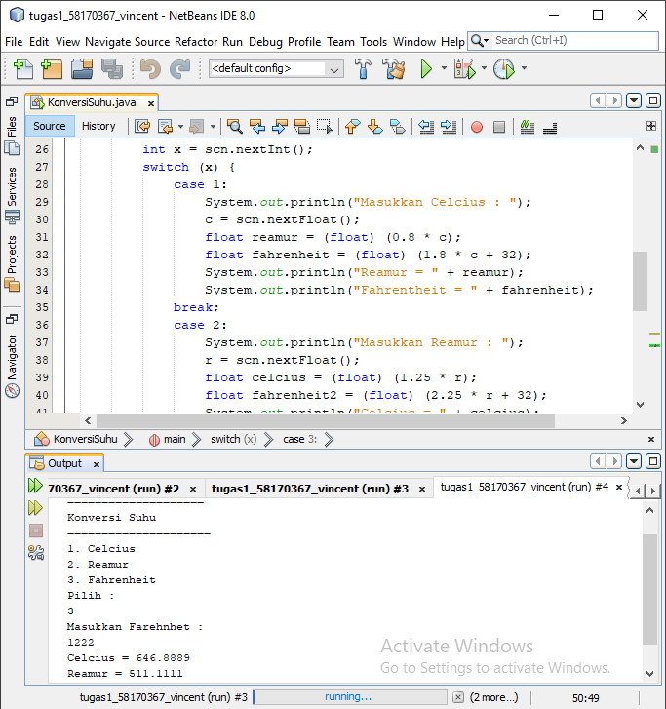

package Pertemuan9_percabangan;

/**

*

* @author VINCENT

*/

import java.util.Scanner;

public class KonversiSuhu {

public static void main(String[] args) {

Scanner scn = new Scanner(System.in);

float c, r, f;

System.out.println("====================");

System.out.println("Konversi Suhu");

System.out.println("=====================");

System.out.println("1. Celcius");

System.out.println("2. Reamur");

System.out.println("3. Fahrenheit");

System.out.println("Pilih : ");

int x = scn.nextInt();

switch (x) {

case 1:

System.out.println("Masukkan Celcius : ");

c = scn.nextFloat();

float reamur = (float) (0.8 * c);

float fahrenheit = (float) (1.8 * c + 32);

System.out.println("Reamur = " + reamur);

System.out.println("Fahrentheit = " + fahrenheit);

break;

case 2:

System.out.println("Masukkan Reamur : ");

r = scn.nextFloat();

float celcius = (float) (1.25 * r);

float fahrenheit2 = (float) (2.25 * r + 32);

System.out.println("Celcius = " + celcius);

System.out.println("Fahrentheit = " + fahrenheit2);

break;

case 3:

System.out.println("Masukkan Farehnhet : ");

f = scn.nextFloat();

float reamur2 = (float) (0.4444444444 * f- 32);

float celcius2 = (float) (0.555555555556 * f - 32);

System.out.println("Celcius = " + celcius2);

System.out.println("Reamur = " + reamur2);

break;

default:

System.out.println("404 Not Found!");

}

}

}

Kasus 7

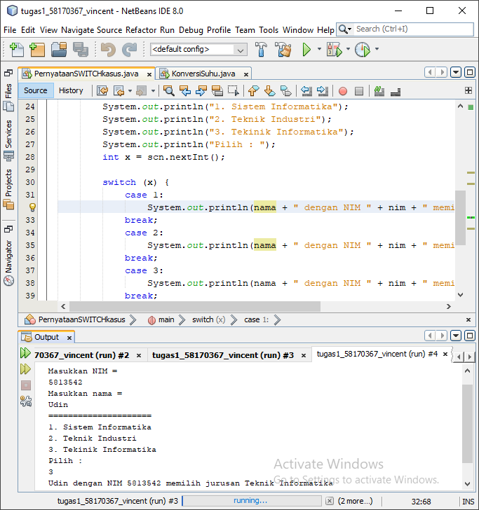

import java.util.Scanner;

public class PernyataanSWITCHkasus {

public static void main(String[] args) {

Scanner scn = new Scanner(System.in);

String nama, nim;

System.out.println("Masukkan NIM = ");

nim = scn.nextLine();

System.out.println("Masukkan nama = ");

nama = scn.nextLine();

System.out.println("=====================");

System.out.println("1. Sistem Informatika");

System.out.println("2. Teknik Industri");

System.out.println("3. Tekinik Informatika");

System.out.println("Pilih : ");

int x = scn.nextInt();

switch (x) {

case 1:

System.out.println(nama + " dengan NIM " + nim + " memilih jurusan Sistem Informatika");

break;

case 2:

System.out.println(nama + " dengan NIM " + nim + " memilih jurusan Teknik Industri");

break;

case 3:

System.out.println(nama + " dengan NIM " + nim + " memilih jurusan Teknik Informatika");

break;

default:

System.out.println("Anak mana?");

}

}

}

Kasus 10

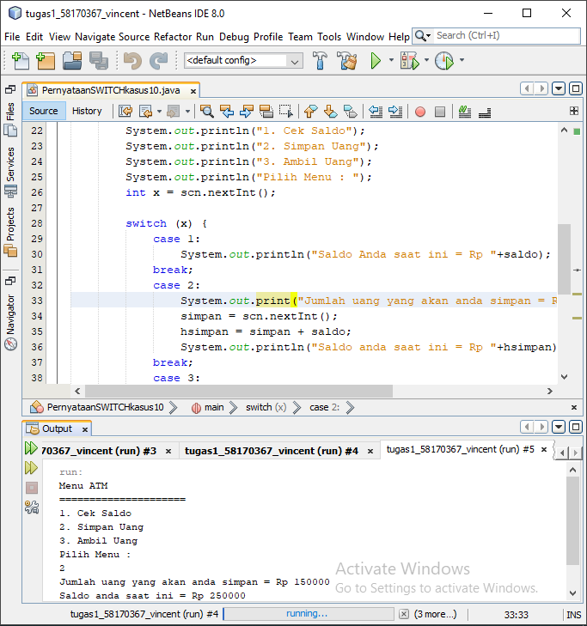

package Pertemuan9_percabangan;

/**

*

* @author VINCENT

*/

import java.util.Scanner;

public class PernyataanSWITCHkasus10 {

public static void main(String[] args) {

Scanner scn = new Scanner(System.in);

int saldo=100000, simpan,hsimpan,ambil,hambil;

System.out.println("Menu ATM");

System.out.println("=====================");

System.out.println("1. Cek Saldo");

System.out.println("2. Simpan Uang");

System.out.println("3. Ambil Uang");

System.out.println("Pilih Menu : ");

int x = scn.nextInt();

switch (x) {

case 1:

System.out.println("Saldo Anda saat ini = Rp "+saldo);

break;

case 2:

System.out.print("Jumlah uang yang akan anda simpan = Rp ");

simpan = scn.nextInt();

hsimpan = simpan + saldo;

System.out.println("Saldo anda saat ini = Rp "+hsimpan);

break;

case 3:

System.out.print("Jumlah uang yang akan anda ambil = Rp ");

ambil = scn.nextInt();

hambil = ambil + saldo;

System.out.println("Saldo anda saat ini = Rp "+hambil);

break;

default:

System.out.print("Salah input");

}

}

}

Kasus 11

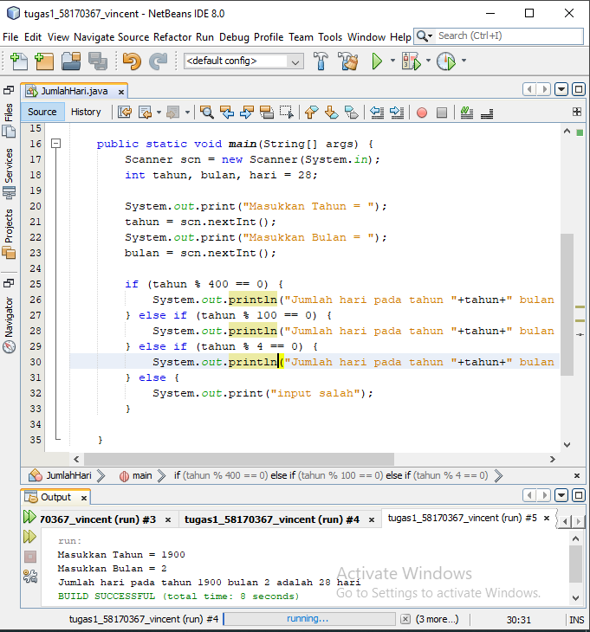

package Pertemuan9_percabangan;

/**

*

* @author VINCENT

*/

import java.util.Scanner;

public class JumlahHari {

public static void main(String[] args) {

Scanner scn = new Scanner(System.in);

int tahun, bulan, hari = 28;

System.out.print("Masukkan Tahun = ");

tahun = scn.nextInt();

System.out.print("Masukkan Bulan = ");

bulan = scn.nextInt();

if (tahun % 400 == 0) {

System.out.println("Jumlah hari pada tahun "+tahun+" bulan "+bulan+" adalah "+hari+" hari");

} else if (tahun % 100 == 0) {

System.out.println("Jumlah hari pada tahun "+tahun+" bulan "+bulan+" adalah "+hari+" hari");

} else if (tahun % 4 == 0) {

System.out.println("Jumlah hari pada tahun "+tahun+" bulan "+bulan+" adalah "+hari+" hari");

} else {

System.out.print("input salah");

}

}

}